Reports Menu

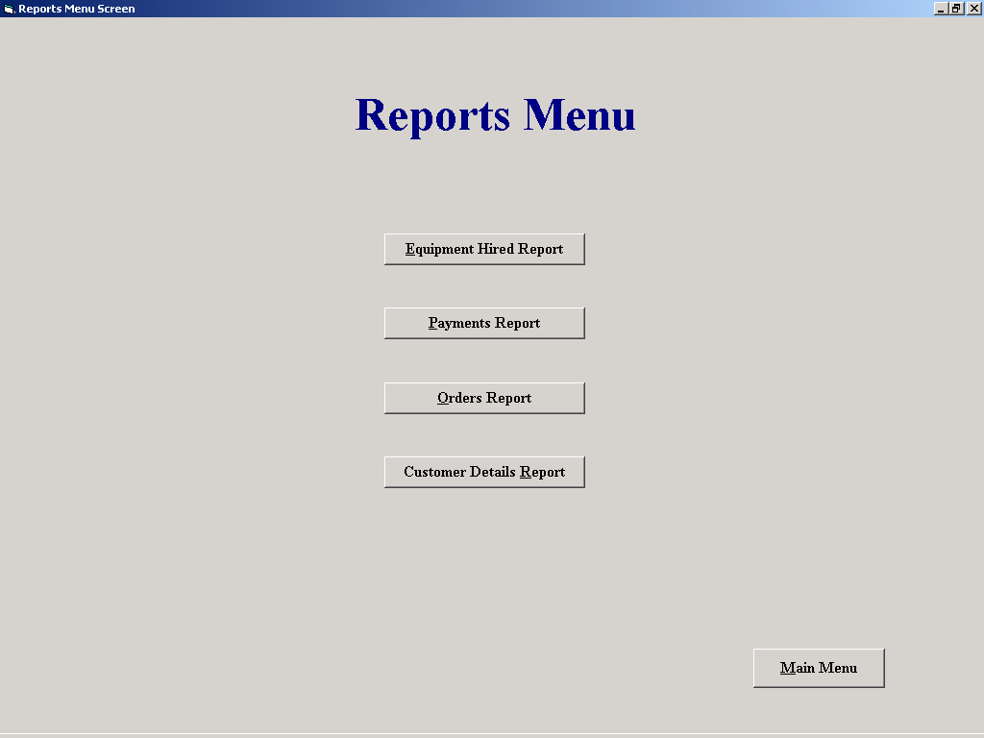

Purpose of the screen
This screen sole purpose is to form an acess point to a number of similar screens, in this case the reports screens

How to get to the screen
Select the “Reports Menu” button on the main menu

How to use the screen
Select the “Equipment Hired Report” button to open the ‘Equipment Hired Report’ screen.
Select the “Payments received Report” button to open the ‘Payments received Report’ screen.
Select the “Orders Report” button to open the ‘Orders Report’ screen.
Select the “Customer Report” button to open the ‘Customer Report’ screen.
Select the “Main Menu” Button to return to the ‘Main Menu’ screen

